Introduction

* Macro
* Forms
* Aha Property (Drupal 6) – Ajax Framework (Drupal 7

**Introduction to Jquery**

* What is Jquery?
  + Javascript Library
  + Reduce Javascript code
  + Crossed browser
  + Visual affects
* The only function in JQuery- $
  + $(‘a.classname’) **Selector**
  + $(‘<div>new content</div>’) **DOM Creation**
  + $.browser.msie **Browser Detection**
    - Not supported in 7
* Jquery as a CSS Selector – Reason why it is popular
  + $(‘.title’) by class
  + $(‘#main’) by id
  + $(‘.sidebar a, .content a’); child elements; multiple element
  + $(‘input[type=text]’); css3 select attribute
  + $(‘img[src$=.png]’) finding images
* Difference between versions
  + $(‘input[type=text]’); Drupal 6/7 (jQuery 1.2.6/1.4x)
  + $(‘input[type=text]’); Drupal 5 (jQuery 1.0.4)
* JQuery Effects
  + $(‘h1’).hide();
  + $(‘h1’).hide(‘slow’);
  + $(‘h1’).hide(3000); 3 second to comlete , jquery uses millisecond
  + $(‘h1’).fadeout(‘slow’);
  + $(‘h1’).slideUp(‘slow’);
  + Toggle Events
    - $(‘h1’).slideToggle();
    - $(‘h1’).toggleClass(‘class-name’);
  + Class Manipulation
    - $(‘h1’).addClass(‘class-name’);
    - $(‘h1’).removeClass(‘class-name’);
* JQuery Chainability
  + Multiple Operations on the same element
    - $(‘h1’).prepend(‘Hello’).append(‘!’).fadeOut().fadeIn();
      * All operations will occur on h1 tag
* Jquery Events
  + Trigger an action in response to the user
  + Most common events:
    - Adding Event
      * .click(functionName); when user clicks
      * .change(functionName); for radio bottons or checkboxes
      * .toggle(function1, function2);
      * .hover(function1, function2); rolling the mouse over
        + Function name is the function to be executed
    - Removing Event
      * $(‘a’).unbind(‘click’, functionName)

Getting Hands On

* Exercise 1
  + Download a ready made Library
    - Place it in your theme directory
      * Create a js folder optional
  + Add scripts in .info
    - Scripts[]= js/library.js
  + Clear Cached data
  + To check if it is loaded
    - Right click and view source
    - As soon as you include a library, Drupal will add two Javascript and jquery
      * Jquery.js and Drupal.js
  + Read the library documentation on how to use particular plugin
  + Create another js file inside your js folder
    - Paste in the js selector and effects of that particular plugin
      * Replace the selector in your function to match your css
      * To test the code: use firebug console
        + Paste it in the right pane and see if it works
      * 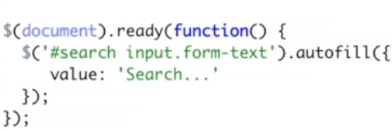
    - Name it and add it into .info file
* Drupal .t (multi language functionality)
  + Collection of special Javascript function
  + 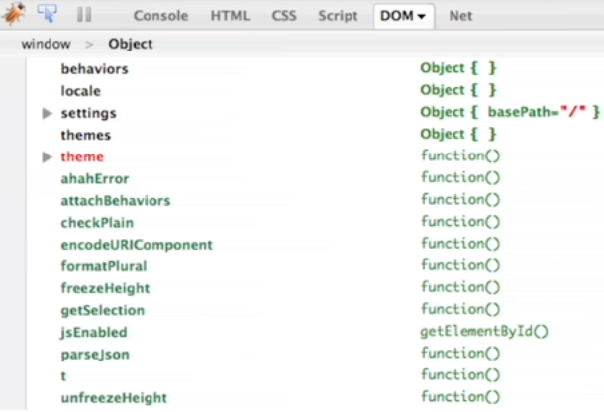
  + 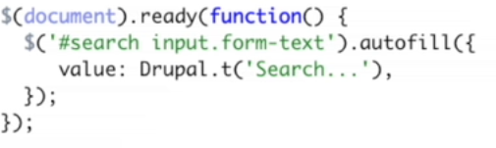

Chapter 4 The Macro Maker Module

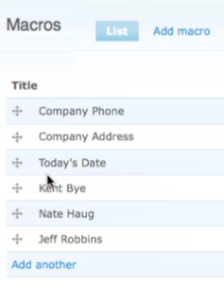

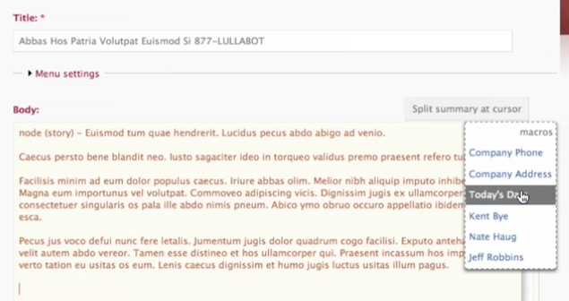

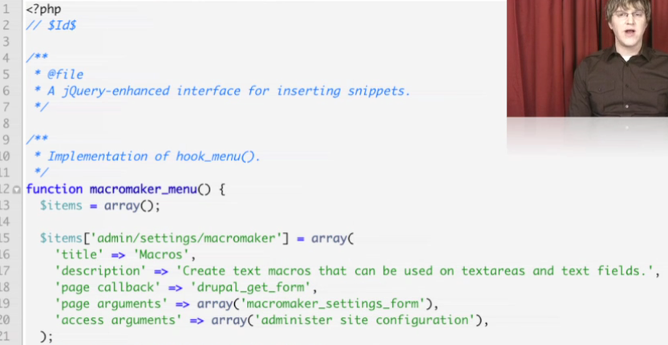

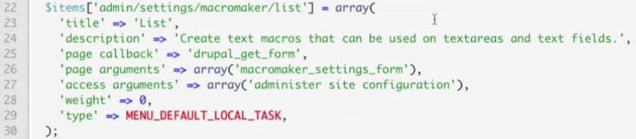

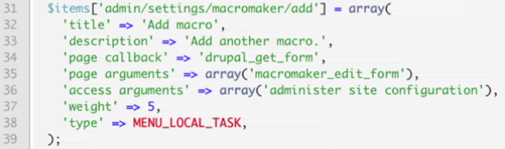

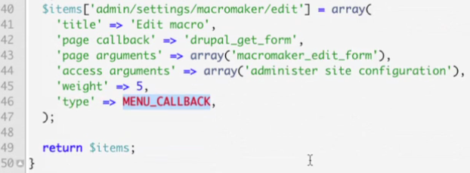

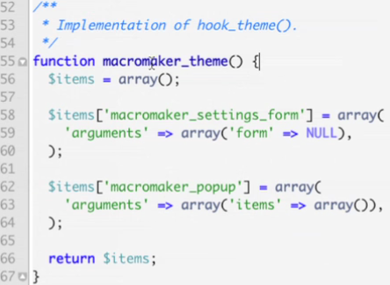

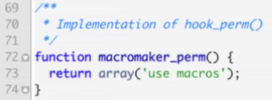

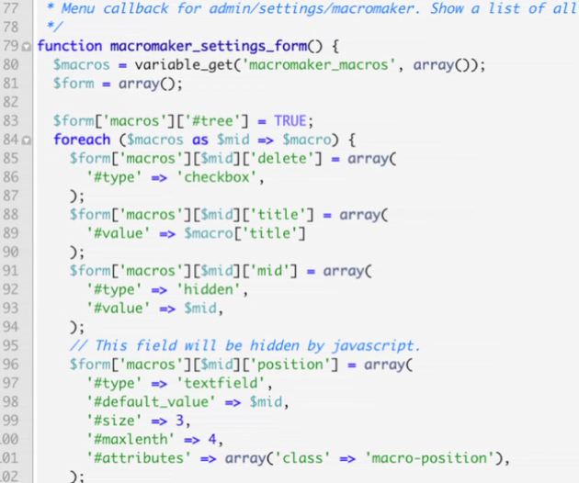

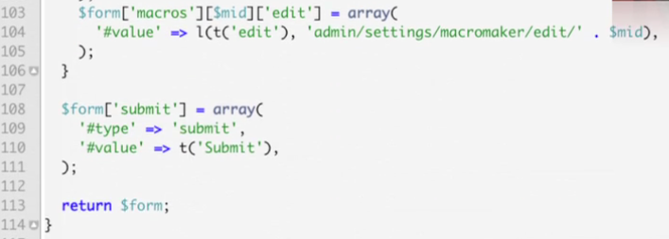

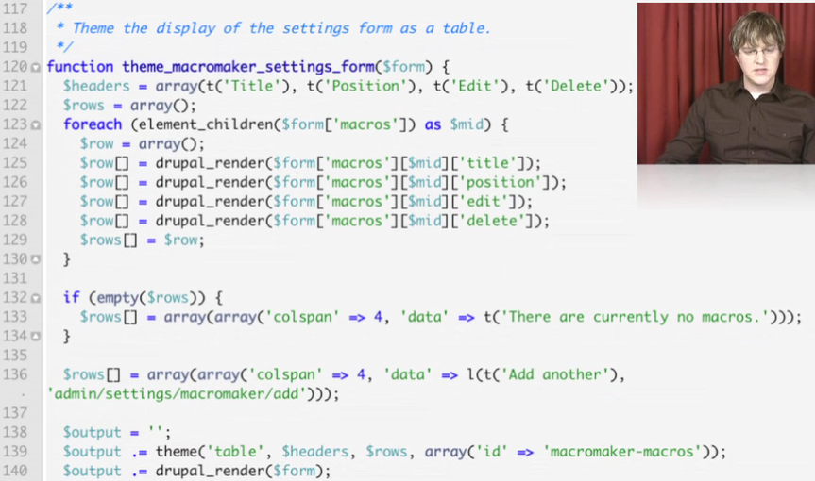

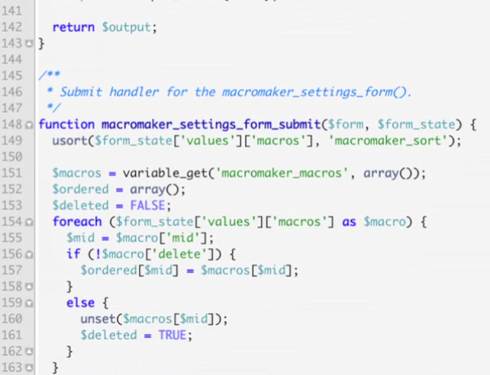

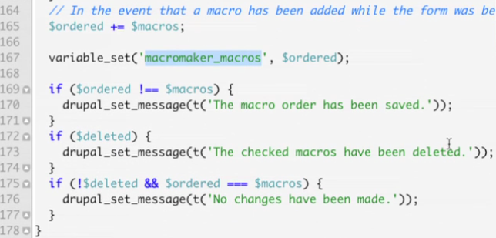

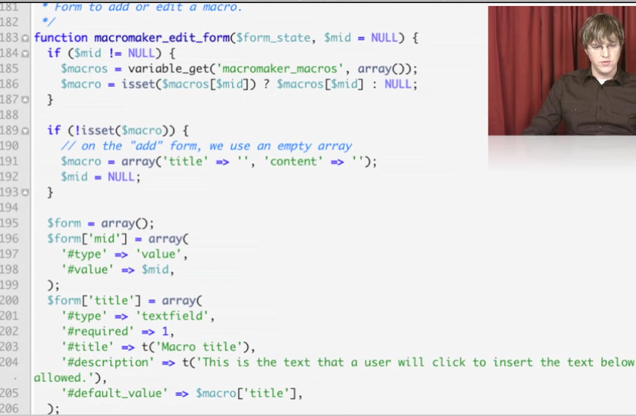

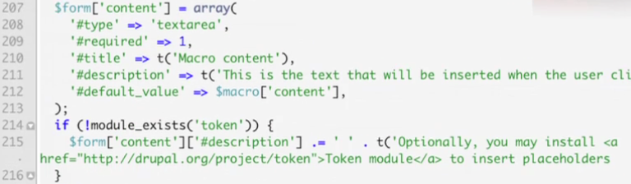

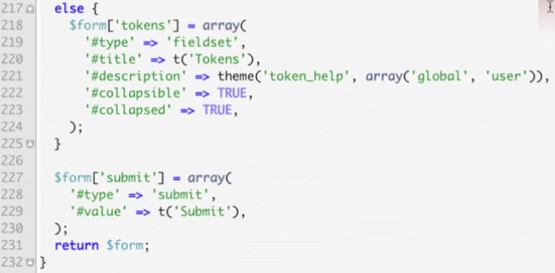

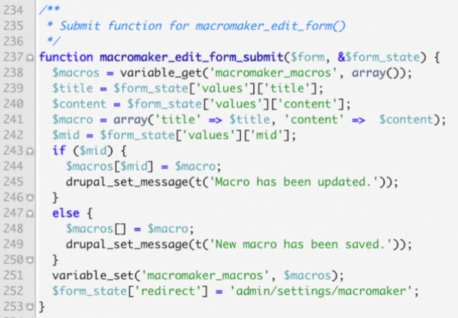

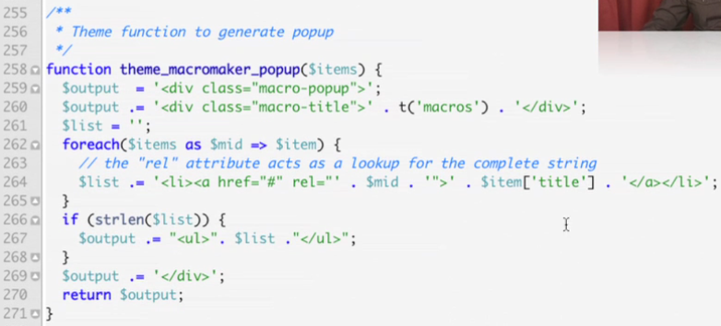

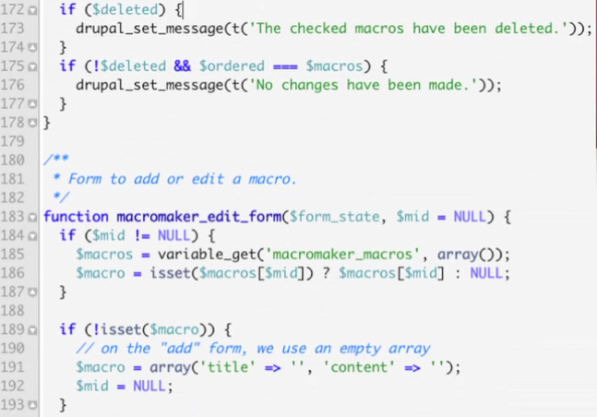

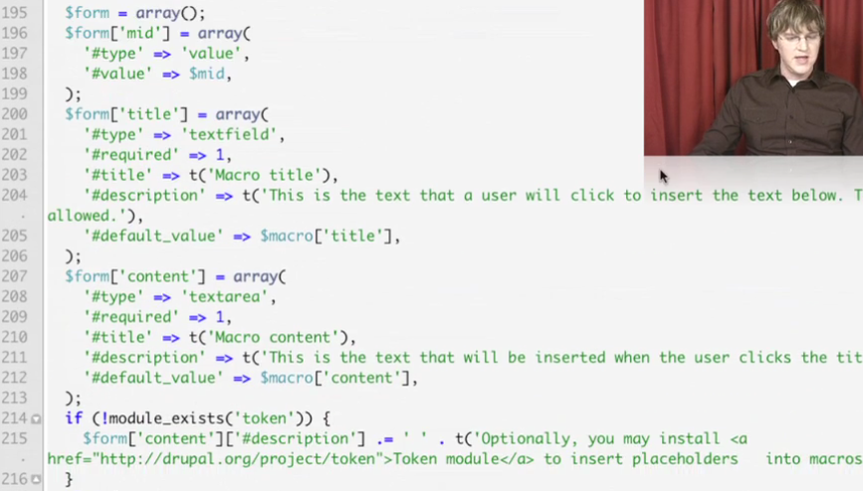

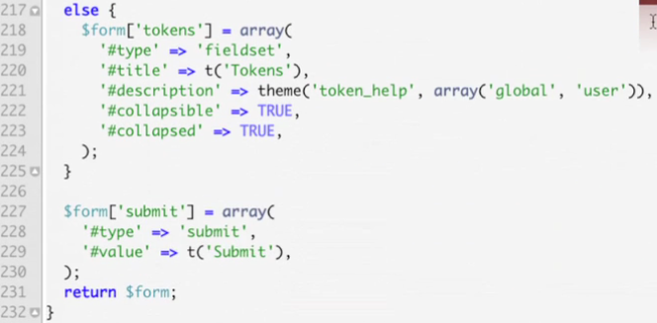

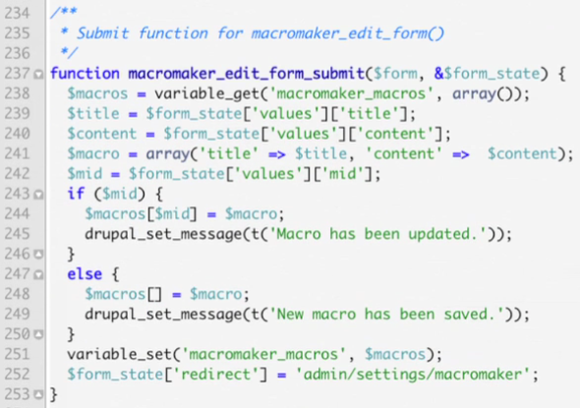

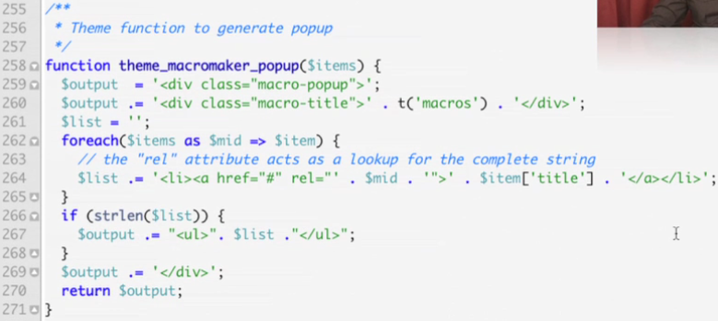

Chapter 5 Adding Javascript to Module

* Drupal_add_js
  + Generalize Drupal Javascript function
  + 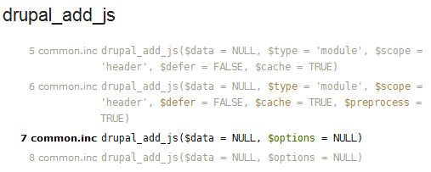
    - Search Drupal_add_js at api.drupal.org
  + 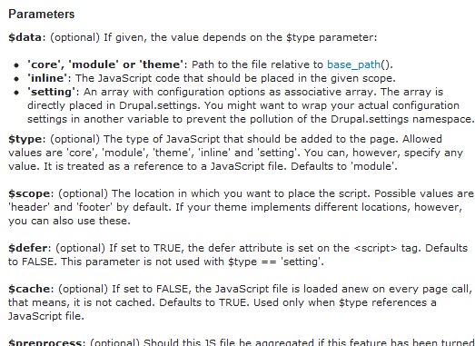
    - http://api.drupal.org/api/drupal/includes%21common.inc/function/drupal_add_js/6
* 
 